PROFIT MAXIMIZING Monopoly

The Monopoly is a abnormal profit maker and using the profit maximization rule MC = MR; we can find the Quantity and the Price. After finding out where MC meets MR, draw a vertical line to the Demand curve, and the corresponding value on the vertical axis is the price. If the monopoly charges a higher price, then less quantity will be bought, and that equilibrium won’t be maximum profit. This equilibrium will continue in the long run, if barriers continue to exist, demand remains consistent, and the cost is maintained. We calculate the cost by drawing a vertical line from where Quantity meets the Average Cost curve to the price line.

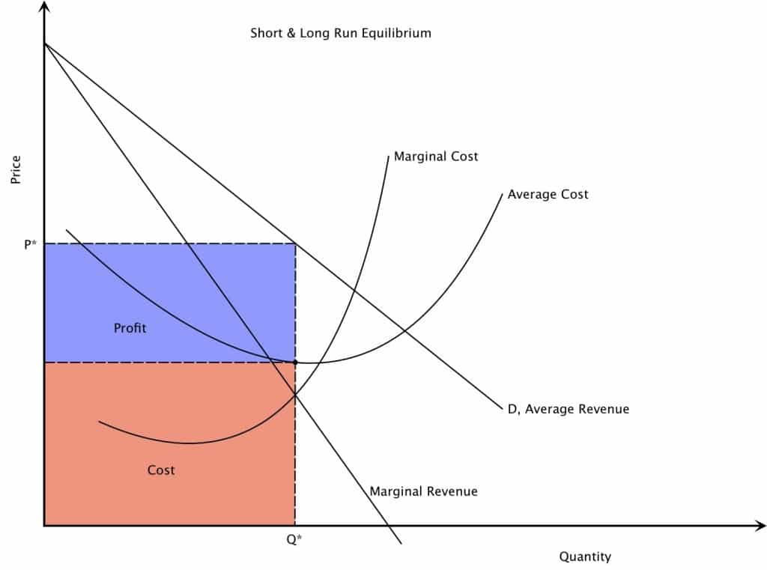

REVENUE MAXIMIZING Monopoly
When the firm wants to maximize revenue, it produces more units but charges a lower price. To find the quantity and price, draw a vertical line to the demand curve from where Marginal Revenue = 0. The price is found by drawing a horizontal line from the demand curve to the price axis (vertical). The cost is found by drawing a vertical line from where Quantity meets the Average Cost curve to the price line. The blue box represent abnormal profits and the red box, cost.

Monopoly TAKING LOSSES
A monopolist can be a loss making one if the Average Cost lies above Average Revenue. In this case the firms costs are greater than its revenue so it makes a loss. The red and blue combined add up to cost. The red box represents revenue and the blue box, loss. The cost is found by drawing a vertical line from where Quantity meets the Average Cost curve to the price line.

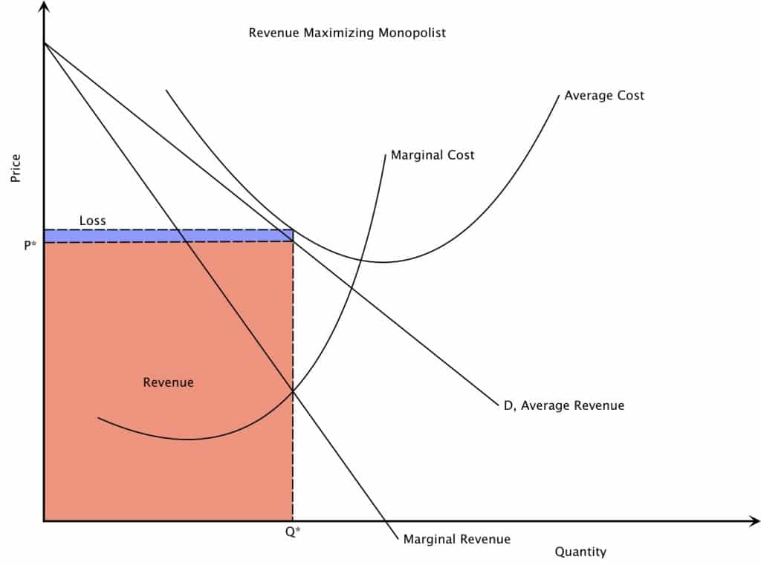

Monopoly being SOCIALLY EFFICIENT or producing SOCIALLY OPTIMAL (or ALLOCATIVE EFFICIENT) levels

At output Q* and price P*, the Monopolistic firm is producing at a lower price but a higher output than a profit or revenue maximizing firm. This is the efficiency in monopolies. Thus, there is a misallocation of resources because of monopoly power. Since monopolies aren’t forced to produce at minimum average cost, so there is productive inefficiency.

